# Lab 1: HTML Basics

Goal of this lab : Understand and practice basic HTML tags.

You will create your own web page by choosing a specific topic. You can use Wikipedia for example to get data about your chosen topic (talk about a technology, a city, a historical event, etc.).

The web page will look like this:

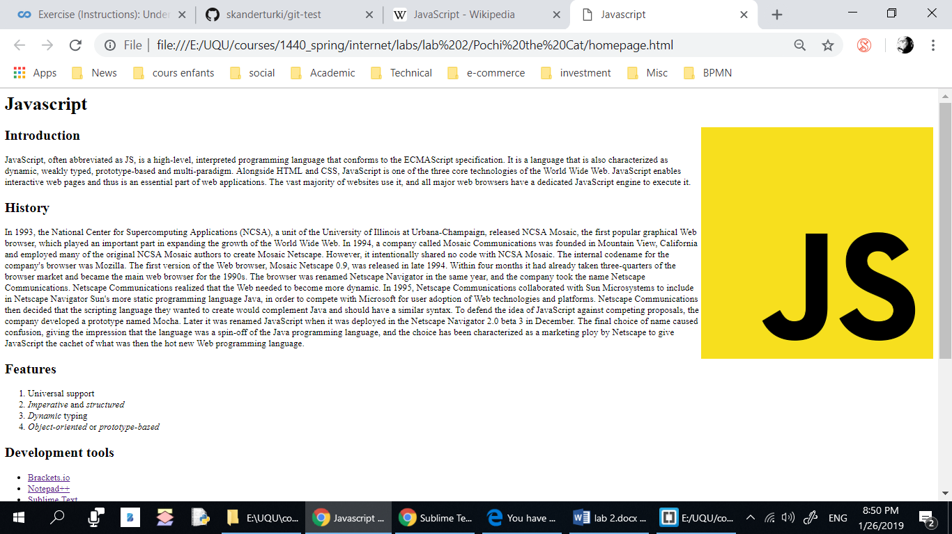

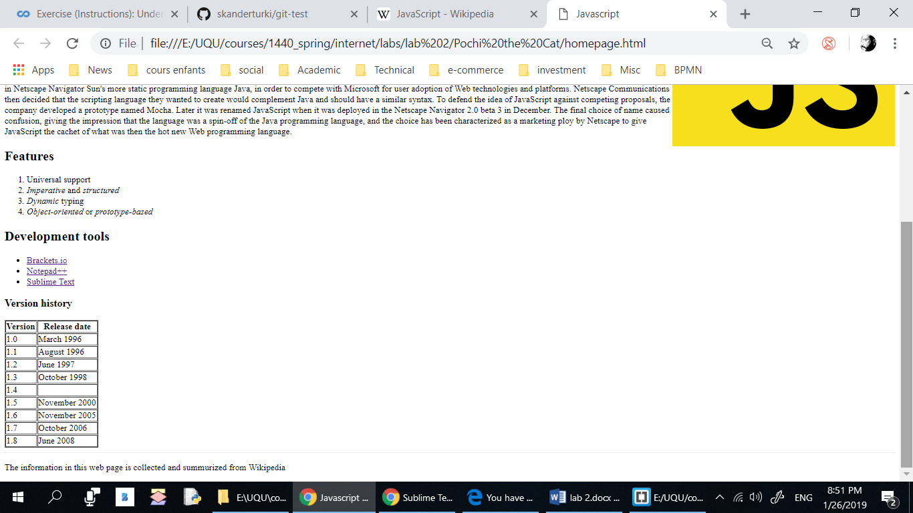

## Development Tool:

Use Visual Studio Code + Google chrome.

## Steps:

1. Create a folder on your Desktop named lab_1.
2. *Start your editor (VSCode).*
3. Create an empty file called index.html.
4. Add the DOCTYPE tag.
5. Start by creating the root **html** tag.
6. Add a **head** section and a **body** section. Add a **title** tag.
7. Add the page encoding tag.
8. Save your file and check if it is working by opening it in a browser.
9. Add a heading h1 for the page.
10. Add one or more paragraphs of text among the subheadings, making sure to put each of your paragraphs in **p** tags.
11. Add a list under a subheading.
12. Add hyperlinks to the external website where you got the data (Wikipedia page?)
13. Add a footer section using the **Footer** tag containing the author name and the date.
14. Find an image on the web and save it to the folder where your web page is saved. Then include the image to your document using the img tag. Image files vary widely in size, so you might find that your image is too large on the page when viewed in a browser. In this case, you can modify the **width** attribute. Do not forget to specify the alt attribute.
15. Add an **alignment** attribute to your **img** tag. Adding **align=right** to the example above puts the image on the right side of the window, allowing text to appear to its left.
16. Add a table. Add an "border" attribute to make the border visible. Add all the necessary tags (tr, th, td) inside the table to organize the content.
17. Add a cell in the table header that spans two columns.